|  |  |
| --- | --- |
| Name | Ishwarya M |
| Team ID | PNT2022TMID04956 |
| Maximum mark | 2 marks |

**ASSIGNMENT 4**

Customer Segmentation Analysis

# Downloading and Loading the Dataset

import numpy as np import pandas as pd

import matplotlib.pyplot as plt import seaborn as sns

import warnings warnings.filterwarnings("ignore")

data = pd.read_csv('Mall_Customers.csv') data.head()

CustomerID Gender Age Annual Income (k$) Spending Score (1-100) 0 1 Male 19 15 39

1 2 Male 21 15 81

2 3 Female 20 16 6

3 4 Female 23 16 77

4 5 Female 31 17 40

# Performing Visualizations

## Univariate Analysis Histplot

sns.histplot(data['Annual Income (k$)'], color="darkblue")

<AxesSubplot:xlabel='Annual Income (k$)', ylabel='Count'>

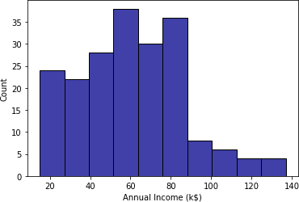

## Box Plot

sns.boxplot(data['Annual Income (k$)'], color="purple")

<AxesSubplot:xlabel='Annual Income (k$)'>

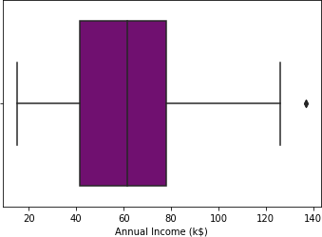

## Dist Plot

sns.distplot(data['Annual Income (k$)'], color="darkgreen")

<AxesSubplot:xlabel='Annual Income (k$)', ylabel='Density'>

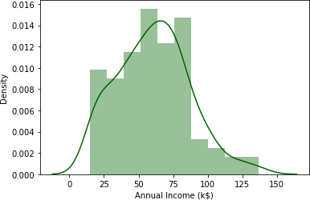

## Bi-variate Analysis Barplot

plt.figure(figsize=(16,6)) sns.barplot(data['Age'],data['Annual Income (k$)'])

<AxesSubplot:xlabel='Age', ylabel='Annual Income (k$)'>

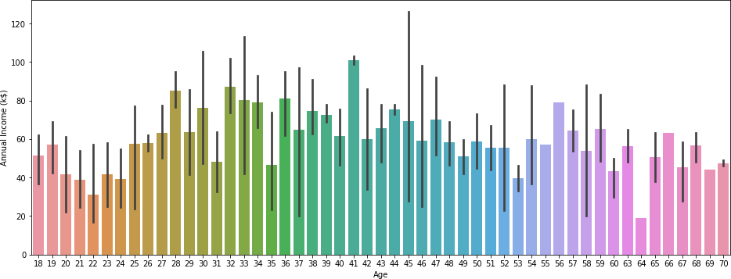

## Lineplot

sns.lineplot(data['Annual Income (k$)'], data['Spending Score (1- 100)'], color="red")

<AxesSubplot:xlabel='Annual Income (k$)', ylabel='Spending Score (1- 100)'>

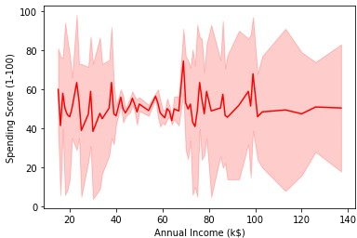

## Multi-variate Analysis

sns.pairplot(data=data[["Age", "Gender","Spending Score (1- 100)","Annual Income (k$)"]])

<seaborn.axisgrid.PairGrid at 0x298ddce51c0>

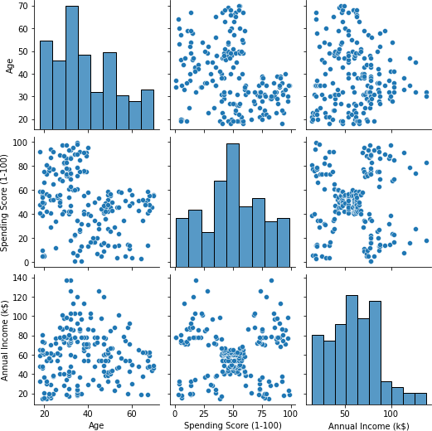

## Correlation between the different attributes

sns.heatmap(data.corr(),annot=True)

<AxesSubplot:>

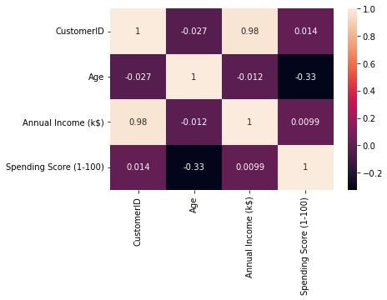

# Performing Descriptive Statistics on the Dataset

data.describe()

CustomerID Age Annual Income (k$) Spending Score (1-

100)

count 200.000000 200.000000 200.000000

|  |  |  |
| --- | --- | --- |
| 200.000000 |  | |
| mean 100.500000 | 38.850000 | 60.560000 |
| 50.200000 |  |  |
| std 57.879185 | 13.969007 | 26.264721 |
| 25.823522 |  |  |
| min 1.000000 | 18.000000 | 15.000000 |

1.000000

25% 50.750000 28.750000 41.500000

34.750000

50% 100.500000 36.000000 61.500000

50.000000

75% 150.250000 49.000000 78.000000

73.000000

max 200.000000 70.000000 137.000000

99.000000

data.info data.shape

(200, 5)

# Check for Missing values

data.isnull().any() *#Inference: The dataset has no null values*

CustomerID False

Gender False

Age False

Annual Income (k$) False Spending Score (1-100) False dtype: bool

data.drop('CustomerID',axis=1,inplace=True) data.head()

Gender Age Annual Income (k$) Spending Score (1-100) 0 Male 19 15 39

1 Male 21 15 81

2 Female 20 16 6

3 Female 23 16 77

4 Female 31 17 40

# Finding the outliers and replacing them

**for** i **in** data:

**if** data[i].dtype=='int64': q1=data[i].quantile(0.25) q3=data[i].quantile(0.75) iqr=q3-q1 upper=q3+1.5*iqr lower=q1-1.5*iqr

data[i]=np.where(data[i] >upper, upper, data[i]) data[i]=np.where(data[i] <lower, lower, data[i])

## After removing outliers, boxplot will be like

plt.boxplot(data['Age'])

{'whiskers': [<matplotlib.lines.Line2D at 0x298de535e20>,

<matplotlib.lines.Line2D at 0x298de545130>], 'caps': [<matplotlib.lines.Line2D at 0x298de545400>,

<matplotlib.lines.Line2D at 0x298de5456d0>],

'boxes': [<matplotlib.lines.Line2D at 0x298de535b50>], 'medians': [<matplotlib.lines.Line2D at 0x298de545940>], 'fliers': [<matplotlib.lines.Line2D at 0x298de545c70>], 'means': []}

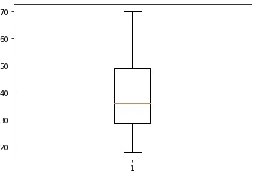

plt.boxplot(data['Annual Income (k$)'])

{'whiskers': [<matplotlib.lines.Line2D at 0x298de59d9a0>,

<matplotlib.lines.Line2D at 0x298de59dc10>], 'caps': [<matplotlib.lines.Line2D at 0x298de59dee0>,

<matplotlib.lines.Line2D at 0x298de5ac1f0>],

'boxes': [<matplotlib.lines.Line2D at 0x298de5904f0>], 'medians': [<matplotlib.lines.Line2D at 0x298de5ac4c0>], 'fliers': [<matplotlib.lines.Line2D at 0x298de5ac790>], 'means': []}

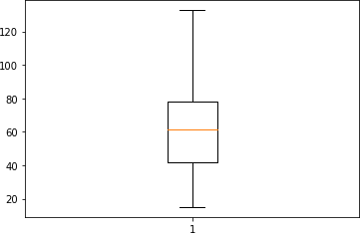

plt.boxplot(data['Spending Score (1-100)'])

{'whiskers': [<matplotlib.lines.Line2D at 0x298de6034c0>,

<matplotlib.lines.Line2D at 0x298de603790>], 'caps': [<matplotlib.lines.Line2D at 0x298de603a60>,

<matplotlib.lines.Line2D at 0x298de603d30>],

'boxes': [<matplotlib.lines.Line2D at 0x298de6031f0>], 'medians': [<matplotlib.lines.Line2D at 0x298de60f040>], 'fliers': [<matplotlib.lines.Line2D at 0x298de60f310>], 'means': []}

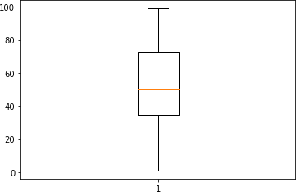

# Checking for categorical columns and performing encoding

from sklearn.preprocessing import LabelEncoder l_en = LabelEncoder()

data['Gender'] = l_en.fit_transform(data['Gender']) data.head()

Gender Age Annual Income (k$) Spending Score (1-100)

|  |  |  |  |  |
| --- | --- | --- | --- | --- |
| 0 | 1 | 19.0 | 15.0 | 39.0 |
| 1 | 1 | 21.0 | 15.0 | 81.0 |
| 2 | 0 | 20.0 | 16.0 | 6.0 |
| 3 | 0 | 23.0 | 16.0 | 77.0 |
| 4 | 0 | 31.0 | 17.0 | 40.0 |

# Scaling the data

from sklearn.preprocessing import MinMaxScaler scaler = MinMaxScaler()

data_scaled = scaler.fit_transform(data) data_scaled[0:5]

|  |  |  |
| --- | --- | --- |
| array([[1. | , 0.01923077, 0. | , 0.3877551 ], |
| [1. | , 0.05769231, 0. | , 0.81632653], |
| [0. | , 0.03846154, 0.00849257, 0.05102041], | |
| [0. | , 0.09615385, 0.00849257, 0.7755102 ], | |
| [0. | , 0.25 , 0.01698514, 0.39795918]]) | |

# Performing any of the clustering algorithms

from sklearn.cluster import KMeans km = KMeans()

res = km.fit_predict(data_scaled) res

array([4, 4, 1, 1, 1, 1, 5, 1, 0, 1, 0, 1, 5, 1, 4, 4, 1, 4, 0, 1, 4,

4,

5, 4, 5, 4, 5, 4, 5, 1, 0, 1, 0, 4, 5, 1, 5, 1, 5, 1, 5, 4, 0,

1,

5, 1, 5, 1, 1, 1, 5, 4, 1, 0, 5, 0, 5, 0, 1, 0, 0, 4, 5, 5, 0,

4,

5, 5, 4, 1, 0, 5, 5, 5, 0, 4, 5, 4, 1, 5, 0, 4, 0, 5, 1, 0, 5,

1,

1, 5, 5, 4, 0, 5, 1, 4, 5, 1, 0, 4, 1, 5, 0, 4, 0, 1, 5, 0, 0,

0,

0, 1, 5, 4, 1, 1, 5, 5, 5, 5, 4, 5, 5, 2, 1, 6, 3, 2, 0, 2, 3,

2,

1, 6, 3, 6, 7, 2, 3, 6, 7, 2, 1, 6, 3, 2, 3, 6, 7, 2, 3, 2, 7,

6,

7, 6, 3, 6, 3, 6, 5, 6, 3, 6, 3, 6, 3, 6, 7, 2, 3, 2, 3, 2, 7,

6,

3, 2, 3, 2, 7, 6, 3, 6, 7, 2, 7, 2, 7, 6, 7, 6, 3, 6, 7, 6, 7,

2,

3, 2])

data1 = pd.DataFrame(data_scaled, columns = data.columns) data1.head()

Gender Age Annual Income (k$) Spending Score (1-100)

|  |  |  |  |  |
| --- | --- | --- | --- | --- |
| 0 | 1.0 | 0.019231 | 0.000000 | 0.387755 |
| 1 | 1.0 | 0.057692 | 0.000000 | 0.816327 |
| 2 | 0.0 | 0.038462 | 0.008493 | 0.051020 |
| 3 | 0.0 | 0.096154 | 0.008493 | 0.775510 |
| 4 | 0.0 | 0.250000 | 0.016985 | 0.397959 |

data1['kclus'] = pd.Series(res) data1.head()

Gender Age Annual Income (k$) Spending Score (1-100) kclus 0 1.0 0.019231 0.000000 0.387755 4

1 1.0 0.057692 0.000000 0.816327 4

2 0.0 0.038462 0.008493 0.051020 1

3 0.0 0.096154 0.008493 0.775510 1

4 0.0 0.250000 0.016985 0.397959 1

data1['kclus'].unique() array([4, 1, 5, 0, 2, 6, 3, 7])

data1['kclus'].value_counts()

|  |  |
| --- | --- |
| 5 | 40 |
| 1 | 37 |
| 0 | 26 |
| 4 | 25 |
| 6 | 21 |
| 3 | 19 |
| 2 | 18 |
| 7 | 14 |

Name: kclus, dtype: int64 import matplotlib.pyplot as plt

fig,ax = plt.subplots(figsize=(15,8)) sns.scatterplot(x=data1['Annual Income (k$)'],

y=data1['Spending Score (1-100)'], hue=data1['kclus'], palette='PuBuGn')

plt.show()

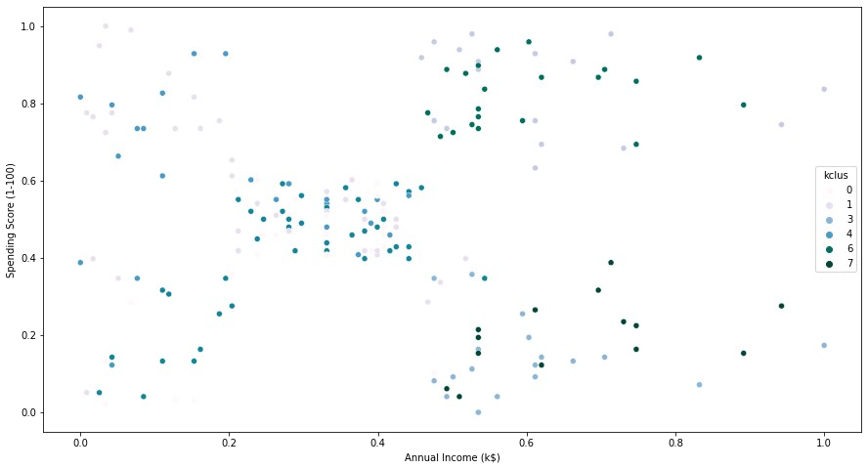

ind = data1.iloc[:,0:4] ind.head()

Gender Age Annual Income (k$) Spending Score (1-100) 0 1.0 0.019231 0.000000 0.387755

1 1.0 0.057692 0.000000 0.816327

2 0.0 0.038462 0.008493 0.051020

|  |  |  |  |  |
| --- | --- | --- | --- | --- |
| 3 | 0.0 | 0.096154 | 0.008493 | 0.775510 |
| 4 | 0.0 | 0.250000 | 0.016985 | 0.397959 |

dep = data1.iloc[:,4:] dep.head()

kclus

|  |  |
| --- | --- |
| 0 | 4 |
| 1 | 4 |
| 2 | 1 |
| 3 | 1 |
| 4 | 1 |

# Splitting dataset into train and test data

from sklearn.model_selection import train_test_split x_train,x_test,y_train,y_test = train_test_split(ind,dep,test_size=0.3,random_state=1) x_train.head()

|  |  |  |  |  |  |  |
| --- | --- | --- | --- | --- | --- | --- |
|  | Gender | Age | Annual | Income (k$) | Spending | Score (1-100) |
| 116 | 0.0 | 0.865385 |  | 0.424628 |  | 0.428571 |
| 67 | 0.0 | 0.961538 |  | 0.280255 |  | 0.479592 |
| 78 | 0.0 | 0.096154 |  | 0.331210 |  | 0.520408 |
| 42 | 1.0 | 0.576923 |  | 0.203822 |  | 0.357143 |
| 17 | 1.0 | 0.038462 |  | 0.050955 |  | 0.663265 |

x_test.head()

|  |  |  |  |  |  |  |
| --- | --- | --- | --- | --- | --- | --- |
|  | Gender | Age | Annual | Income (k$) | Spending | Score (1-100) |
| 58 | 0.0 | 0.173077 |  | 0.263270 |  | 0.510204 |
| 40 | 0.0 | 0.903846 |  | 0.195329 |  | 0.346939 |
| 34 | 0.0 | 0.596154 |  | 0.152866 |  | 0.132653 |
| 102 | 1.0 | 0.942308 |  | 0.399151 |  | 0.591837 |
| 184 | 0.0 | 0.442308 |  | 0.713376 |  | 0.387755 |

y_train.head() kclus

|  |  |
| --- | --- |
| 116 | 5 |
| 67 | 5 |
| 78 | 1 |
| 42 | 0 |
| 17 | 4 |

y_test.head()

kclus

|  |  |
| --- | --- |
| 58 | 1 |
| 40 | 5 |
| 34 | 5 |
| 102 | 0 |
| 184 | 7 |

from sklearn.linear_model import LinearRegression lr = LinearRegression()

lr.fit(x_train,y_train) LinearRegression()

pred_test = lr.predict(x_test) pred_test[0:5]

array([[3.95042116],

[3.52672483],

[3.51129248],

[2.16561932],

[5.40782042]])

# Measuring the performance using metrics

from sklearn.metrics import mean_squared_error,mean_absolute_error from sklearn.metrics import accuracy_score

mse = mean_squared_error(pred_test,y_test) print("The Mean squared error is: ", mse)

The Mean squared error is: 3.785711485954305 rmse = np.sqrt(mse)

print("The Root mean squared error is: ", rmse)

The Root mean squared error is: 1.945690490790944

mae = mean_absolute_error(pred_test,y_test) print("The Mean absolute error is: ", mae)

The Mean absolute error is: 1.7183473427088407

acc = lr.score(x_test,y_test) print("The accuracy is: ", acc)

The accuracy is: 0.2718229670102855